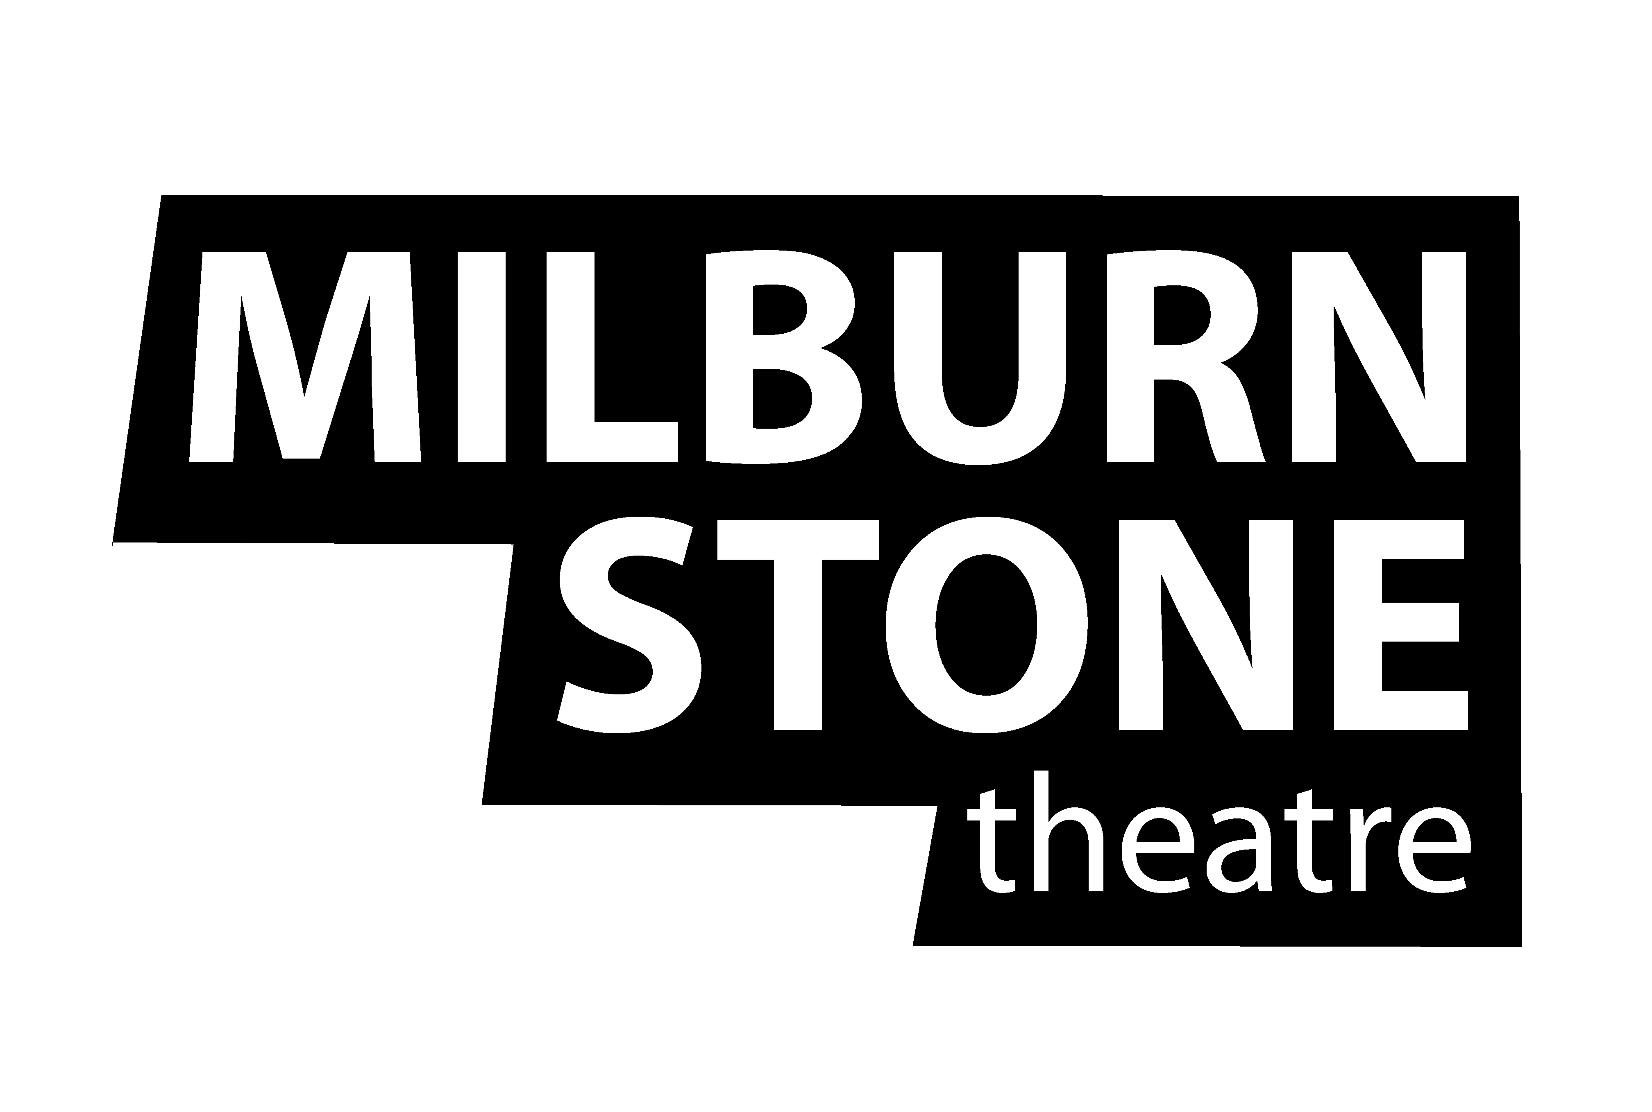
Production Proposal Information
for the 2024 / 2025 Season

All directors must submit a proposal for any production to be considered for inclusion in the Milburn Stone Theatre’s upcoming season. Proposals will be reviewed by the Season Selection Committee and viable candidates will be asked to interview in early January. Final recommendations will be made in the late January by the season selection committee and will then be reviewed by the Milburn Stone Theatre staff.

Proposals will be reviewed in the following areas:
- Fulfillment of the Milburn Stone Theatre Mission & Vision
- Feasibility from a financial, practical, and logistical standpoint
- Ability to broaden and enhance the theatre’s audience base and community image.

Please review the information provided in this packet to familiarize yourself with what Milburn Stone Theatre has done in the past as well as proposed dates for our upcoming season. The following information is included in this packet (click the link to access the document):
- Theatrical Rights Companies
  - List includes all major rights houses that hold musicals and plays.
  - Milburn Stone Theatre has worked with most of these and has existing relationship with them.
- Milburn Stone Theatre’s Production History
  - List of all shows presented at Milburn Stone Theatre since opening in 1992.
  - Indicates shows that have been performed multiple times in our history.
  - Please note – we usually do not repeat a show that has occurred in the past 4-5 seasons. Exceptions are made, and if you are proposing a show that has been done recently, please address in your Artistic Vision Statement why you feel it is important to be presenting again so soon.

Proposal Application
Once you have read through all the information provided in this packet, you will then use the link at the bottom of this document to complete your Proposal Application. During the application process you will be asked to upload your Artistic Vision Statement as well as your theatrical resume, and any resumes of production staff that you would be considering as part of your proposal.

Production Dates for the 2024/2025 Season
The following is the list of all the dates we are looking to perform productions throughout the season. Our August 2024 Show has already been selected therefore we are not taking proposals for that time slot.

When selecting a time slot for your production pleased remember that for all slots Tech Week starts the Sunday prior to the opening date for each slot and that week is mandatory for all production staff. For the December production, Tech will start with the Monday & Tuesday prior to Thanksgiving, and then continue the Monday after Thanksgiving.

September 3 Shows over 1 Weekend September 6, 7, & 8
October 6 Shows over 2 Weekends October 11, 12, 13, 18, 19, & 20
December 6 Shows over 2 Weekends December 6, 7, 8, 13, 14, & 15
January 3 Shows over 1 Weekend January 24, 25, & 26
February / March 6 Shows over 2 Weekends February 21, 22, 23, 28, March 1 & 2
April 6 Shows over 2 Weekends April 4, 5, 6, 11, 12, & 13
May 3 Shows over 1 Weekend May 10 & 11
June 6 Shows over 2 Weekends June 13, 14, 15, 20, 21, & 22

Production Staff
In the application you will be given the chance to upload resumes for a Music Director, Choreographer, and/or Stage Manager you would be interested in working with on your production. While we encourage directors to submit as many members of a production staff as they would like, the final approval/official hiring of any production staff members lies at the discretion of the Milburn Stone Theatre’s staff and is a separate consideration from the production approval process.

We do offer stipends for our production staff members when hired on for a show. The final stipend amount is determined once the seasons budget has been set along with individual production budgets. The range of pay for each production staff position is:
- Director $500 - $750
- Music Director $650 - $850
- Choreographer $450 - $650
- Stage Manager $450 - $650

If your show is chosen a further discussion will be had about remaining production staff members and if there are others you would like Milburn Stone Theatre Staff to consider for areas like Set Design, Costume Design, Lighting Design, Props Master, etc.

If you do not have potential production staff members, Milburn Stone Theatre maintains a listing of potential production staff members and in addition solicits for positions once a season is announced. The Theatre Staff will consult and work with the existing production staff in securing new production staff as needed.

Artistic Vision Statement
The Artistic Vision Statement is the centerpiece of this proposal packet. Please upload an Artistic Vision Statement (PDF or Word Format) for your production. While the bulk of your proposal will be typed, you are welcome to include sketches, images, or diagrams within your document. It must all be included in the one document that you are uploading.

Please cover the following topics in your Artistic Vision Statement:
- A synopsis of the production, including previous production information, significance and a complete character breakdown. If you are making adjustments or deviations from “traditional casting practices” for the production, please list them here as well.
- Why this particular production should be produced by the Milburn Stone Theatre
- How this production will be produced at the Milburn Stone Theatre. Please go in depth in regard to special effects, scenery, blocking, etc. that you envision being part of the production and how this will be an enhancement to the final product, or how obstacles will be surmounted.
- In relation to our audiences and the community, who you believe this production is for. Please detail special groups or communities that will be attracted to the production and community organizations that may benefit from this production.

Time Line
Proposals Accepted November 1, 2023 – December 10, 2023
Notification Emails for Presentation Invitation December 20, 2023
Presentation of Proposal to MST Staff &
Season Selection Committee January 8, 2024 – January 11, 2024
Acceptance or Decline Notifications March 1, 2024

Production Proposal Application

Supplemental Documents:

- MST Production History

- Theatrical Rights Companies

